**A**

**PROJECT REPORT**

**ON**

**“COLLEGE ATTENDANCE SYSTEM”**

SUBMITTED TO

BHAVAN’S SHREE H.J. DOSHI INFOTMATION

TECHNOLOGY INSTITUTE,

JAMNAGAR

**AFFILICATED TO**

**SAURASHTRA UNIVERSITY, RAJKOT**

****

**FOR THE COURSE OF**

**BACHELOR OF COMPUTER APPLICATION (5th SEM)**

**SUBMITTED BY:**

**TAHER HADIYANAWALA & HEMANG JOSHI**

**UNDER THE GUIDENCE OF**

**RAVI SIR**

ACKNOWLEDGEMENT

The satisfaction that accompanies that the successful completion of any task would be incomplete without the mention of people whose ceaseless cooperation made it possible, whose constant guidance and encouragement crown all efforts with success.

We are grateful to our project guide Mr. Ravi Oza Sir for the guidance, inspiration and constructive suggestions that helpful us in the preparation of this project.

We also thank our colleagues who have helped in successful completion of the project.

# Table of Contents

|  |  |  |
| --- | --- | --- |
| No. | Title | Page No. |
| 1. | Introduction | 4 |
| 2. | Feasibility Study | 6 |
| 3. | Working Of Present System | 7 |
| 4. | Characteristics of The Proposed System | 8 |
| 5. | Data Tables | 9 |
| 6. | Data Flow Diagrams | 12 |
| 7. | Entity Relationship Diagram | 14 |
| 8. | Screen Shots Of Form | 15 |
| 9. | Conclusion | 20 |
| 10. | Bibliography | 21 |

**INTRODUCTION**

Attendance Management System is a software developed for daily student attendance in schools, collges and institutes. If facilitates to access the attendance information of a particular student in a particular class. The information is sorted by the operators, which will be provided by the teacher for a particular class. This system will also help in evaluating attendance eligibility criteria of a student.

**Purpose:-**

The purpose of developing attendance management system is to computerized the tradition way of taking attendance. Another purpose for developing this software is to generate the report automatically at the end of the session or in the between of the session.

**Scope**:-

The scope of the project is the system on which the software is installed, i.e. the project is developed as a desktop application, and it will work for a particular institute. But later on the project can be modified to operate it online.

**HARDWARE AND SOFTWARE**

**REQUIREMENTS**

**Hardware Requirements:**

* + - Pentium III or Advanced Processor
    - 512 MB RAM
    - 20 GB Hard disk or onwards
    - Monitor 1024 \* 768 resolutions

**Software Requirements:**

* + - Windows 2007
    - Microsoft SQL Server 2012
    - Microsoft Visual Studio 2012

**ECONOMICALLY FEASIBILITY**

The system being developed is economic with respect to School or Collage’s point of view. It is cost effective in the sense that has eliminated the paper work completely.

The system is also time effective because the calculations are automated which are made at the end of the month or as per the user requirement.

The result obtained contains minimum errors and are highly accurate as the data is required.

**TECHNICAL FEASIBILITY**

The technical requirement for the system is economic and it does not use any other additional Hardware and software.

**BEHAVIORAL FEASIBILITY**

The system working is quite easy to use and learn due to its simple but attractive interface. User requires no special training for operating the system.

**WORKING OF PRESENT SYSTEM**

In the present system all work is done on paper. The whole session attendance is stored in register and at the and of the session the reports are generated. We are not interested in generating report in the middle of the session or as per the requirement because it takes more time in calculation.

**DISADVANTAGES OF PRESENT WORKING SYSTEM**

**Not User Friendly:**

The existing system is not user friendly because the retrieval of data is very slow and data is not maintained efficiently.

**Difficulty in report generating:**

We require more calculations to generate the report so it is generated at the end of the session. And the student not get a single chance to improve their attendance.

**Manual control**:

All calculations to generate report is done manually so there is greater chance of errors.

**Lots of paperwork**:

Existing system requires lot of paper work. Loss of even a single register/record led to difficult situation because all the papers are needed to generate the reports.

**Time consuming**:

Every work is done manually so we cannot generate report in the middle of the session or as per the requirement because it is very time consuming.

**CHARACTERSTIC OF THE PROPOSED SYSTEM**

**User Friendly:**

The proposed system is user friendly because the retrieval and storing of data is fast and data is maintained efficiently. Moreover the graphical user interface is provided in the proposed system, which provides user to deal with the system very easily.

**Reports are easily generated:**

Reports can be easily generated in the proposed system so user can generate the report as per the requirement (monthly) or in the middle of the session. User can give the notice to the students so he/she become regular.

**Very less paper work:**

The proposed system requires very less paper work. All the data is feted into the computer immediately and reports can be generated through computers. Moreover work become very easy because there is no need to keep data on papers.

**Computer operator control:**

Computer operator control will be there so no chance of errors. Moreover storing and retrieving of information is easy. So work can be done speedily and in time.

##### **DATA TABLE**

##### **User Table**

##### D:\taher\college\C#\NewClgAttdMgnmt\NewClgAttdMgnmt\Documentation\Clg_User.PNG

##### 

##### 

##### Student Table

##### D:\taher\college\C#\NewClgAttdMgnmt\NewClgAttdMgnmt\Documentation\Clg_StudInfo.png

Attendance Table

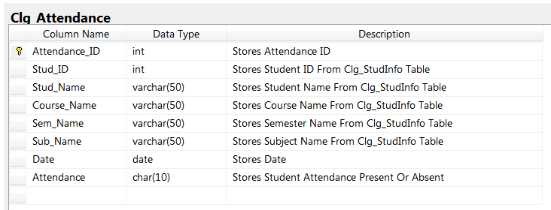

Course Table

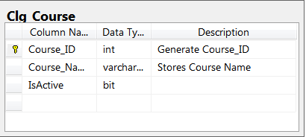

Semester Table

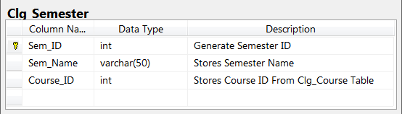

Subject Table

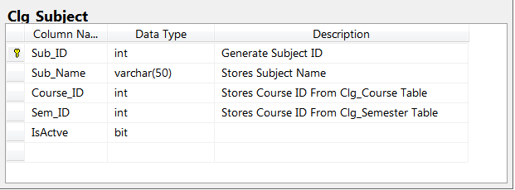

## **DATA FLOW DIAGRAM**

## 0-level DFD**:**

System

Output

User/Administrator

## 1-level DFD

**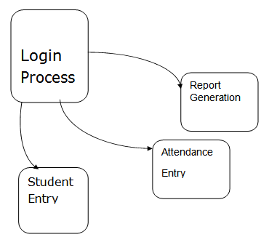**

## 

## 2-level DFD

## D:\taher\college\C#\NewClgAttdMgnmt\NewClgAttdMgnmt\Documentation\2dfd.PNG

## **E R DIAGRAM**

## D:\taher\college\C#\NewClgAttdMgnmt\NewClgAttdMgnmt\Documentation\Clg_ERD.png

##### **SCREEN SHOTS**

##### **Login Form :**

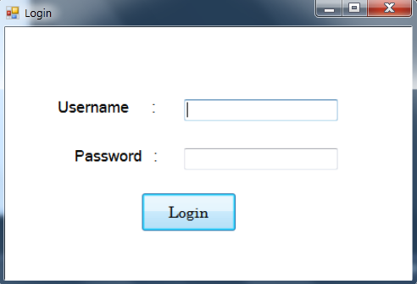

This login Form is made For Security purpose. So only Authenticated User only Access in to the Project.

##### **Home Page**

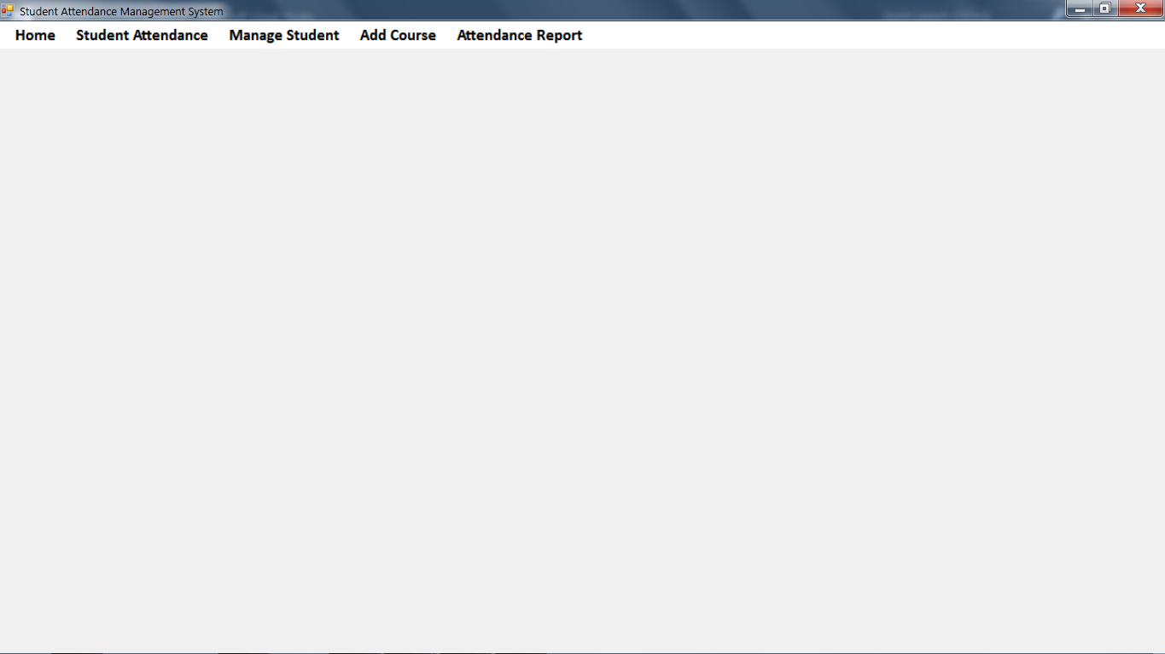

This form is showed when authorized User enters his correct User Name and Password. This Form gives the option to Manage Student,Take Student Attendance and View Report Of Attendance.

##### **Student Information Form**

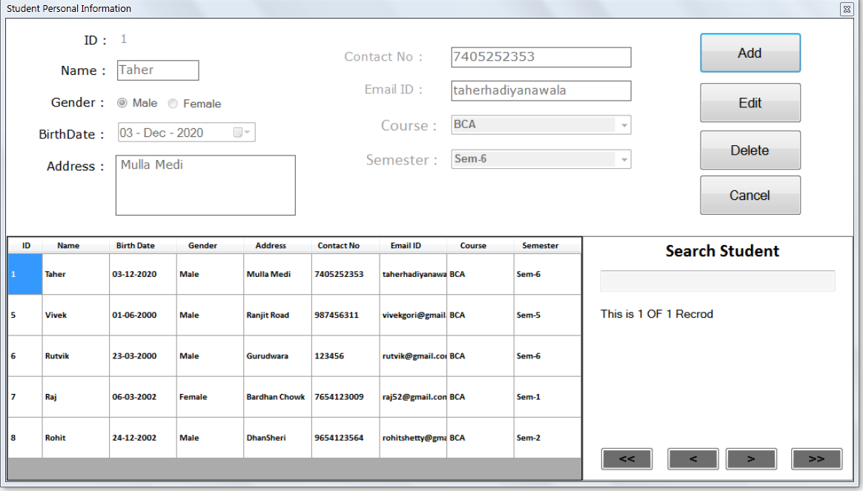

This form enables the User to fill the Students Details and there Semester where the Student Id will change automatically when a Student is saved in the Database.

In This Form User Also Search Student and Edit Or Delete The Record Of Student.

##### **Course Management Form**

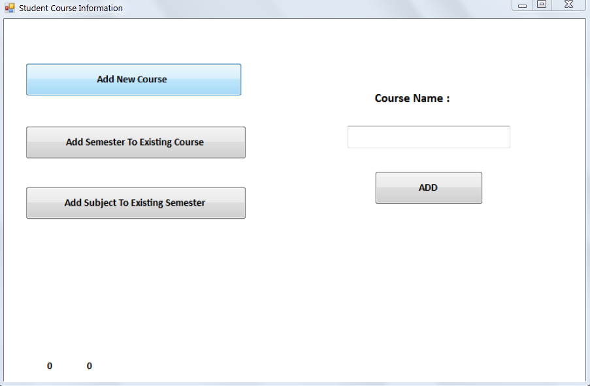

This Form is made for User to Add New Course, Add Semester To Existing Course And Subject.

##### **Attendance Form**

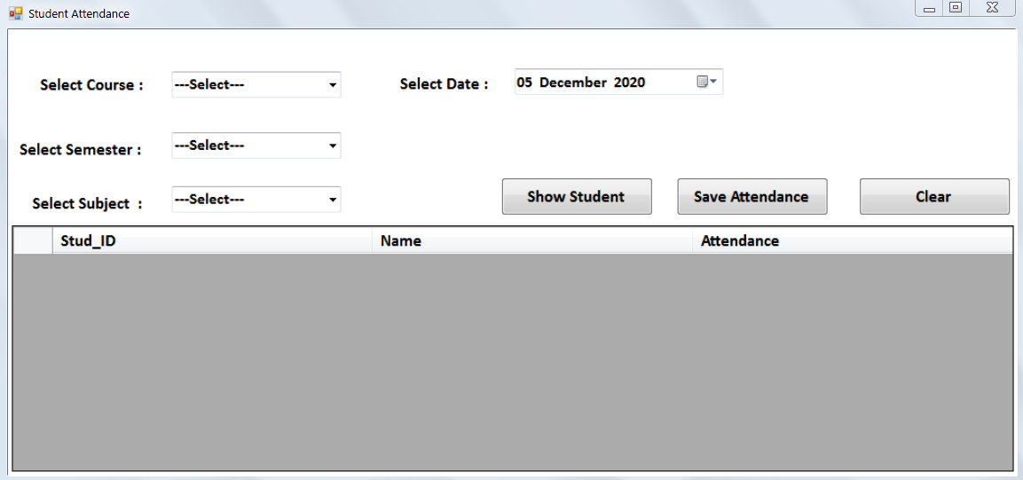

This form is made to take Student Attendance and Store Attendance in Database and Generate Report Of Attendance

This Form is used to choose subjects and the month for which attendance is to be filled up and show a list of students. When a User click to corresponding Check box and click on save the students will be stated present and their attendance is added.

# CONCLUSION

The Attendance Management System is developed using C#.NET fully meets the objectives of the system which it has been developed. The system has reached a steady state where all bugs have been eliminated.

The system is operated at a high level of efficiency and all the teachers and user associated with the system understands its advantage. The system solves the problem. It was intended to solve as requirement specification.

# BIBLIOGRAPHY

The Bibliography contains references to all the documents that were used to develop the application.

#### [www.stackoverflow.com](http://www.stackoverflow.com/)

* www.c#corner.com
* [www.tutorialspoint.com](http://www.tutorialspoint.com/)